DAY 10 – AZURE SYNAPSE

Creating a SQL Synapse service –

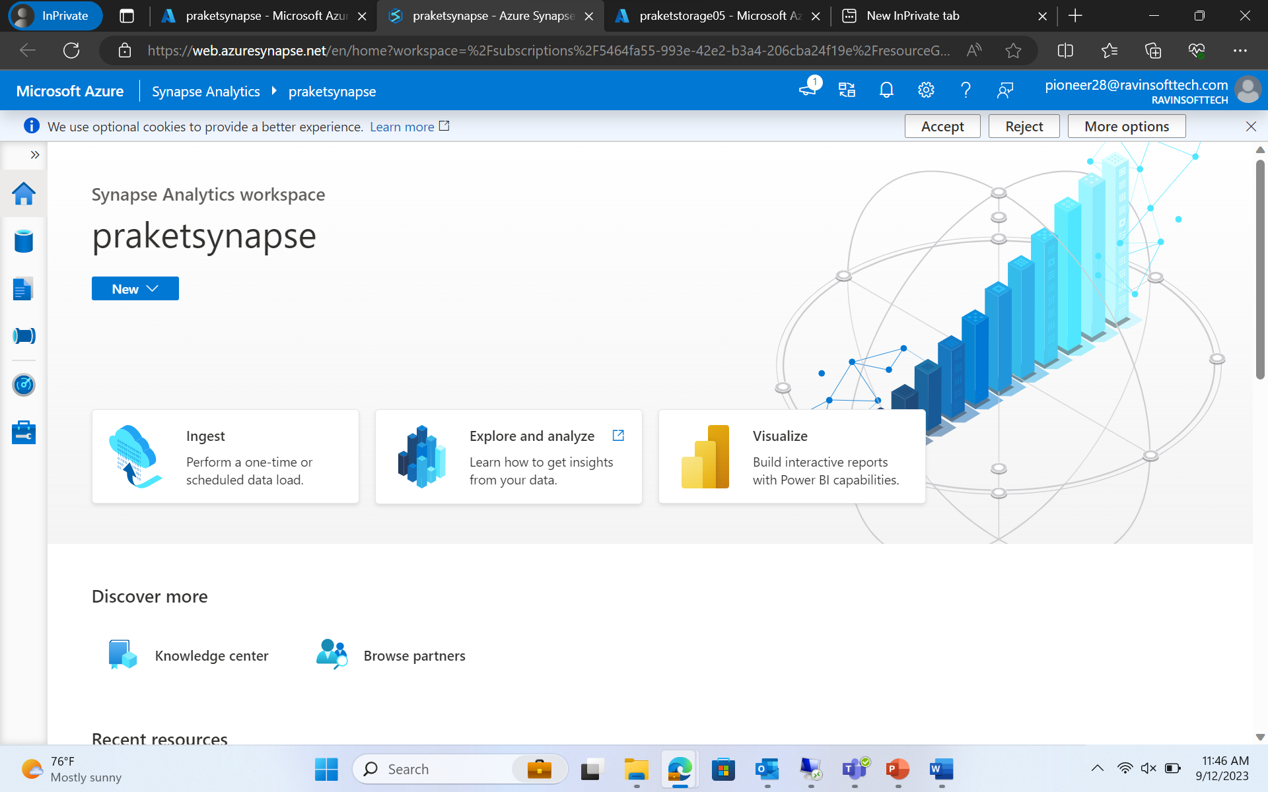

Every Azure Synapse Analytics workspace comes with serverless SQL pool endpoints that you can use to query data in the Azure Data Lake (Parquet, Delta Lake, delimited text formats), Azure Cosmos DB, or Dataverse.

Dedicated SQL pool refers to the enterprise data warehousing features that are available in the Azure   
Dedicated SQL pool represents a collection of Analytical resources that are provisioned when using Synapse SQL.

While the serverless doesn't store data, only access data from storage accounts and scale the MPP environment automatically, the dedicate SQL Pool keeps a static number of servers according to the service level we choose and a constant number of distributions - always 60.

Serverless SQL pools

Idle for either structure or unstructured data. Data can be stored in different file formats (raw or parquet) The compute associated with the serverless SQL pool is managed and allocated by

Microsoft Seamless data transformation without any infrastructure in place

Dedicated SQL pools:

Data is stored in relational tables

If you need an optimized compute strategy for performance requirements, go with Dedicated option to increase the Data warehouse units)

Require dedicated servers before performing any operation The performance is based on DWU (Data Warehouse Units)

